***Your Parish Community is Seeking Connection with You!***

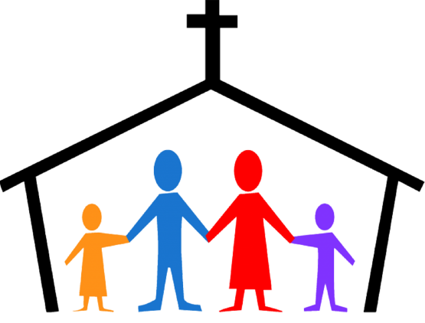

***Community is life-giving***

*We are better together than we are alone*

**

**Para Hills Modbury Catholic Parish**

“We, though many, are one body in Christ, and individually members one of another.”

Romans 12:5

As parishioners you are at the heart of our Catholic community, and it is my very great pleasure to welcome you into our parish.

Fr Kym Spurling

**Parish Priest**

My Church is composed of people like me.

I help make it what it is.

It will be friendly, if I am.

Its pews will be filled, if I help fill them.

It will do great work, if I work.

It will make generous gifts to many causes, if I am a generous giver.

It will bring other people into its worship and fellowship, if I invite and bring them.

It will be a church of loyalty and love, of fearlessness and faith, and a church with noble spirit,

if I, who make it what it is, am filled with these same things.

Therefore, with the help of God, I shall dedicate myself to the task of being all the things that I want my church to be. Amen

*Please complete both sides of this page, tear it off, place it in the envelope* and return it to the parish office or leave with a Welcomer after Mass.

**✂………………………………………………………………………………………………………………………….**

Family Name: ……………………………………………………………….… Today’s Date: ……/……/……

Address: ………………………………………………………………….…

**Be aware that the information you provide will be used by the Parish strictly in line with our privacy policy. Your details will be held in confidence and will not be shared with others.**

Suburb: ……………………………………………………………….…

Post Code: …………………………

Mobile Phone No: ………………………………………………………………….

Email: ………………………………………………………….………

**Family Members Living at Home**

|  |  |  |  |  |  |  |
| --- | --- | --- | --- | --- | --- | --- |
| **Family Name** | **Given Name** | **M/F** | **DOB** | **Religion** | **Occupation** | **Mobile No.** |
|  |  |  |  |  |  |  |
|  |  |  |  |  |  |  |
|  |  |  |  |  |  |  |
|  |  |  |  |  |  |  |
|  |  |  |  |  |  |  |

*Please Turn Over*

**Giving Commitment**

* **I am a new giver and would like to join the parish Planned Giving Program**

I pledge $................. each  week  fortnight  month  quarter  year

I wish to contribute via  Direct Debit  EFT  Credit Card  Envelopes

*(Forms/Details will be sent to you for Direct Debit, EFT for Credit Card)*

*Please note that giving by Direct Debit, EFT or Credit Card is greatly appreciated as the manual counting and banking of monies and processing of Planned Giving Envelopes represent a significantly higher administrative and security cost to our parish.*

* **I prefer not to join the Planned Giving Program at this time.**

**Signature:** ……………………………………………………… **Date:** ………...……